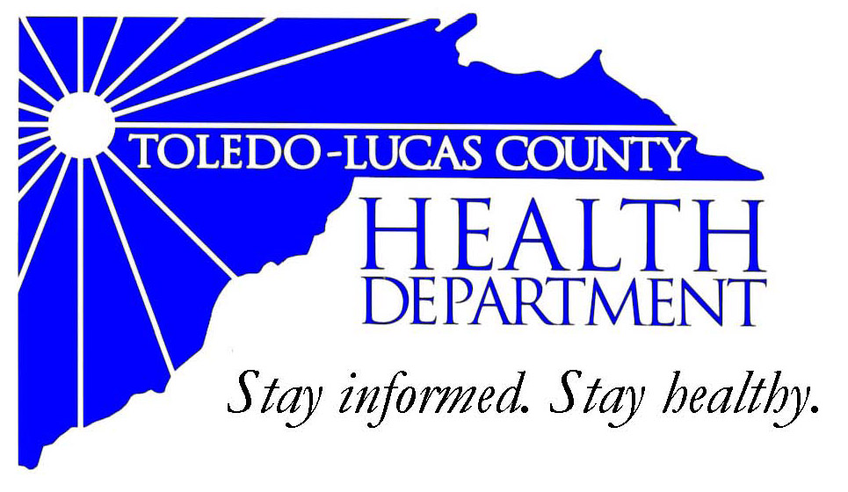
Main Office Western Clinic Site
635 N. Erie St. 330 Oak Terrace Boulevard
Toledo, OH 43604-1317 Holland, Ohio 43528-8993
(419) 213-4100 (419) 213-6255
Fax: (419) 213-4017 Fax: (419) 213-6266

Email: boardofhealth@co.lucas.oh.us
David Grossman, M.D. Larry J. Vasko, R.S., M.P.H
Health Commissioner Deputy Health Commissioner

Lucas County Regional Health District Board Members

Donna A. Woodson, MD, President Perlean Griffin
Robert R. Reinbolt, MBA, PE Matthew S. Heyrman, MPA
Vice President Donald R. Murray
Darlene L. Chaplin, RN A. Debra Nicotra, RN, PhD
Barbara Conover, MSN, RN Barbara Sarantou
Reynald Debroas Hans Schmalzried, PhD, RS
Mary E. Duncan Christopher A. Sherman, MD, MBA

For Immediate Release
October 2, 2013
David Grossman, M.D., Health Commissioner
(419) 213-4018

Health Update: WIC is Open

There have been some confusion and concerns with the government shutdown recently taking effect. Lucas County Women, Infants, and Children (WIC) programs are currently open and operational. Please call your local WIC site if you should have any concerns.
TOLEDO-LUCAS COUNTY CORDELIA-MARTIN HEALTH CENTER
HEALTH DEPARTMENT 430 Nebraska Avenue
635 North Erie Street Toledo, Ohio 43607
Toledo, Ohio 43604 (419) 255-7883 ext. 108
(419) 213-4422

THE TOLEDO HOSPITAL TOLEDO-LUCAS COUNTY
HEALTH DEPARTMENT
2150 West Central Avenue 330 Oak Terrace Boulevard
Suite B Holland, Ohio 43528
Toledo, Ohio 43606 (419) 213-6250
(419) 291-2216
RIVER EAST COMMUNITY ST. VINCENT MERCY FAMILY
HEALTH CENTER CARE CENTER
117 Main St. 2213 Franklin Avenue
Toledo, Ohio 43604 Toledo, Ohio 43620
(419) 697-2705 ext. 317 (419) 251-2433

TOLEDO-LUCAS COUNTY SOUTH SIDE COMMUNITY
HEALTH DEPARTMENT HEALTH CENTER
East Toledo Family Center 1 Aurora Gonzalez Dr.
1020 Varland Ave Toledo, Ohio 43609
Toledo, OH 43605 (419) 241-4230 ext. 208
(419) 693-1116

###
AN EQUAL OPPORTUNITY EMPLOYER
The Toledo-Lucas County Health Department operates in accordance with Title VI of the Civil Rights Act of 1964
Visit us on the web at: www.co.lucas.oh.us/health

