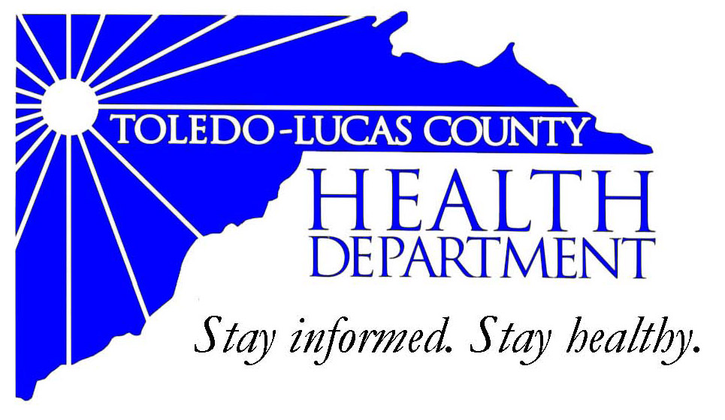
Main Office Western Clinic Site
635 N. Erie St. 330 Oak Terrace Boulevard
Toledo, OH 43604-1317 Holland, Ohio 43528-8993
(419) 213-4100 (419) 213-6255
Fax: (419) 213-4017 Fax: (419) 213-6266

Email: boardofhealth@co.lucas.oh.us
David Grossman, M.D. Larry J. Vasko, R.S., M.P.H
Health Commissioner Deputy Health Commissioner

Lucas County Regional Health District Board Members

Donna A. Woodson, MD, President Perlean Griffin
Robert R. Reinbolt, MBA, PE Matthew S. Heyrman, MPA
Vice President Donald R. Murray
Darlene L. Chaplin, RN A. Debra Nicotra, RN, PhD
Barbara Conover, MSN, RN Barbara Sarantou
Reynald Debroas Hans Schmalzried, PhD, RS
Mary E. Duncan Christopher A. Sherman, MD, MBA

For Immediate Release
April 7, 2014
Public Information Officer
Stacy DeBruyne
(419) 213-4143

Health Information: National Public Health Week (April 7-13th)

Every year in the United States, seven out of 10 deaths are due to preventable chronic diseases such as diabetes and heart disease. In fact, chronic diseases account for a whopping 75 percent of national health care spending, yet only 3 percent of our health care dollars go toward prevention. But there are steps we can take to help turn these numbers around.
The Toledo-Lucas County Health Department is participating in Public Health Week to show people the fun, easy and small steps they can take to make prevention a part of their lives. During the week we will be hosting a table in our front lobby showcasing the different programs that we support in honor of Public Health Week. To give back to our citizens we will also hosting the Toledo Fire and Rescue Department to give out smoke detectors to City of Toledo residents on Tuesday April 8th from 10 am – 2 pm. On Wednesday April 9th from 2 pm – 4 pm the Lucas County Health Coaches will be providing blood pressure screenings to the general public. The rest of the week TLCHD will provide information on breastfeeding, disaster preparedness, WIC, and environmental health.
Since 1995, communities nationwide have celebrated NPHW each April to draw attention to the need to help protect and improve the nation’s health. “National Public Health Week” helps educate and engage Americans in the movement to create a healthier America for ourselves and the generations to come. The hundreds of events that take place this week help showcase the value of supporting prevention and the role that public health agencies, organizations and practitioners play in making prevention possible, said Georges C. Benjamin, MD, FACP, FACEP (E), executive director of the American Public Health Association. “We all have a role to play in making America the healthiest nation in one generation. And it starts with each of us taking the simple preventive steps that lead to better health.”
For more information about National Public Health Week, visit www.nphw.org. To learn more about public health efforts at the Toledo-Lucas County Health Department, please visit
www.lucascountyhealth.com.
###
AN EQUAL OPPORTUNITY EMPLOYER
The Toledo-Lucas County Health Department operates in accordance with Title VI of the Civil Rights Act of 1964
Visit on the web at www.lucascountyhealth.com

