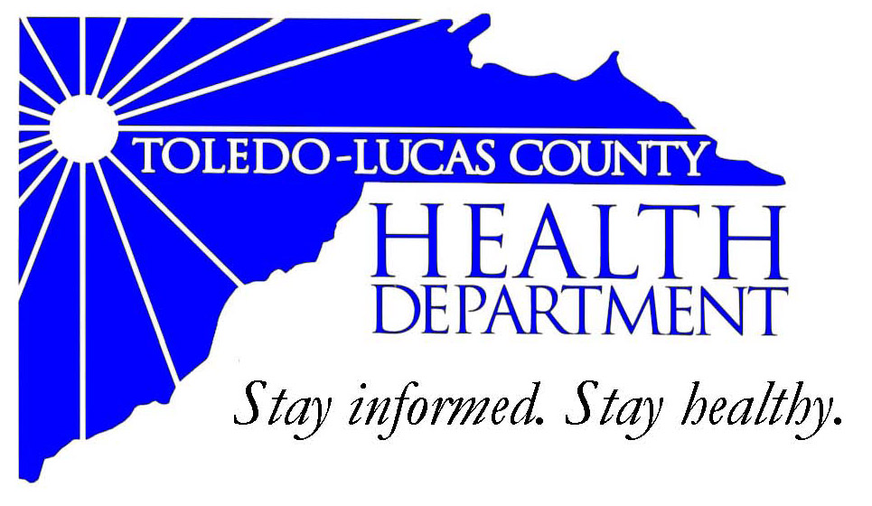
Main Office Western Clinic Site
635 N. Erie St. 330 Oak Terrace Boulevard
Toledo, OH 43604-1317 Holland, Ohio 43528-8993
(419) 213-4100 (419) 213-6255
Fax: (419) 213-4017 Fax: (419) 213-6266

Email: boardofhealth@co.lucas.oh.us
David Grossman, M.D. Larry J. Vasko, R.S., M.P.H
Health Commissioner Deputy Health Commissioner

Lucas County Regional Health District Board Members

Donna A. Woodson, MD, President Perlean Griffin
Robert R. Reinbolt, MBA, PE Matthew S. Heyrman, MPA
Vice President Donald R. Murray
Darlene L. Chaplin, RN A. Debra Nicotra, RN, PhD
Barbara Conover, MSN, RN Barbara Sarantou
Reynald Debroas Hans Schmalzried, PhD, RS
Mary E. Duncan Christopher A. Sherman, MD, MBA

For Immediate Release
March 27, 2014
Public Information Officer
Stacy DeBruyne
(419) 213-4143

Health Information: Juki’s Tattoo

The Toledo-Lucas County Health Department has received the court ruling and settlement for Juki’s Tattoo owner, Kirk Summey. Kirk was sentenced to a total of 540 days at Corrections Center of Northwest Ohio. Of that sentence 480 days will be suspended on his compliance with the following conditions of probation for three years. During probation he must comply with no criminal offenses, no possession of any tattoo equipment, restitution to all Lucas County victims that had to be tested for infectious diseases, and 40 hours of community service to be served in the first four months of probation. The other 60 days of incarceration will be served with 10 days at Corrections Center of Northwest Ohio and 50 days in electronic home monitoring.

###

AN EQUAL OPPORTUNITY EMPLOYER
AN EQUAL OPPORTUNITY EMPLOYER
The Toledo-Lucas County Health Department operates in accordance with Title VI of the Civil Rights Act of 1964
Visit us on the web at: www.co.lucas.oh.us/health
The Toledo-Lucas County Health Department operates in accordance with Title VI of the Civil Rights Act of 1964
Visit us on the web at: www.lucascountyhealth.com

