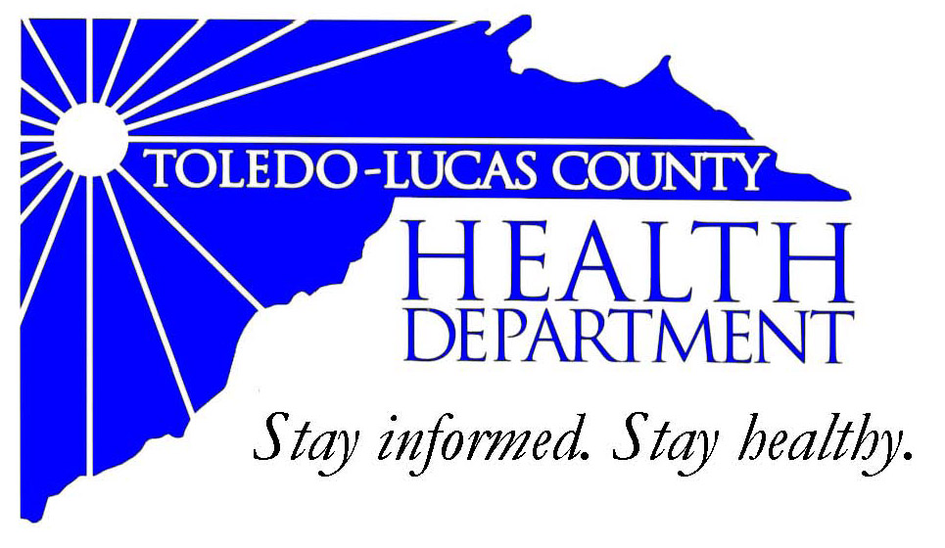
Main Office Western Clinic Site
635 N. Erie St. 330 Oak Terrace Boulevard
Toledo, OH 43604-1317 Holland, Ohio 43528-8993
(419) 213-4100 (419) 213-6255
Fax: (419) 213-4017 Fax: (419) 213-6266

Email: boardofhealth@co.lucas.oh.us
David Grossman, M.D. Larry J. Vasko, R.S., M.P.H
Health Commissioner Deputy Health Commissioner

Lucas County Regional Health District Board Members

Donna A. Woodson, MD, President Perlean Griffin
Robert R. Reinbolt, MBA, PE Matthew S. Heyrman, MPA
Vice President Donald R. Murray
Darlene L. Chaplin, RN A. Debra Nicotra, RN, PhD
Barbara Conover, MSN, RN Barbara Sarantou
Reynald Debroas Hans Schmalzried, PhD, RS
Mary E. Duncan Christopher A. Sherman, MD, MBA

For Immediate Release
January 25, 2014
Public Information Officer
Stacy DeBruyne
(419) 213-4143

Health Advisory: Flu Clinic Closed

Due to the extreme weather conditions the Toledo-Lucas County Health Department must regretfully close its flu clinic today. The current snow emergency is at a Level Two in Lucas County. A Level Two snow emergency in Lucas County means only people with an important need to be on the streets should do so. (The current snow emergency is at a Level Three in Lucas County. A Level Three snow emergency in Lucas County means all roadways are closed to non-emergency personnel.)

We will re-schedule a flu clinic at a later date. Please stay tuned to our website (www.lucascountyhealth.com) for updates.

If you have any questions or concerns please contact the Health Department at 419-213-4218.

###

AN EQUAL OPPORTUNITY EMPLOYER
AN EQUAL OPPORTUNITY EMPLOYER
The Toledo-Lucas County Health Department operates in accordance with Title VI of the Civil Rights Act of 1964
Visit us on the web at: www.co.lucas.oh.us/health
The Toledo-Lucas County Health Department operates in accordance with Title VI of the Civil Rights Act of 1964
Visit us on the web at: www.lucascountyhealth.com

