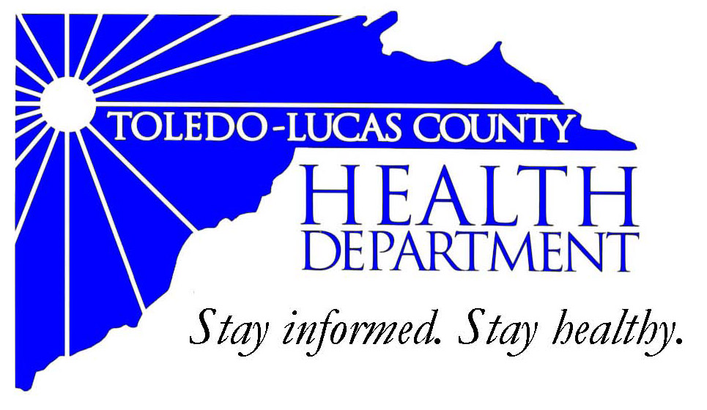
Main Office Western Clinic Site
635 N. Erie St. 330 Oak Terrace Boulevard
Toledo, OH 43604-1317 Holland, Ohio 43528-8993
(419) 213-4100 (419) 213-6255
Fax: (419) 213-4017 Fax: (419) 213-6266

Email: boardofhealth@co.lucas.oh.us
David Grossman, M.D. Larry J. Vasko, R.S., M.P.H
Health Commissioner Deputy Health Commissioner

Lucas County Regional Health District Board Members

Donna A. Woodson, MD, President Perlean Griffin
Robert R. Reinbolt, MBA, PE Matthew S. Heyrman, MPA
Vice President Donald R. Murray
Darlene L. Chaplin, RN A. Debra Nicotra, RN, PhD
Barbara Conover, MSN, RN Barbara Sarantou
Reynald Debroas Hans Schmalzried, PhD, RS
Mary E. Duncan Christopher A. Sherman, MD, MBA

For Immediate Release
December 18th, 2013
David Grossman, M.D., Health Commissioner
(419) 213-4018

Health Information: Press Conference: CareSource Grant Award – Thursday December 19th, 2013 at 10 am.

The Toledo-Lucas County Health Department applied and was awarded a grant from The CareSource foundation for $15,000. This grant comes funded through the Ohio Institute of Equity in Birth Outcomes initiative into The Fund for Public Health in Lucas County . The Fund for Public Health in Lucas County is a 501(c) 3 not-for-profit organization that was formed by the Toledo-Lucas County Health Department to increase its capacity of programs and services to meet the needs of residents in the northwest Ohio region.
The Ohio Institute for Equity in Birth Outcomes is an initiative designed by CityMatCH, in partnership with the State of Ohio, to strengthen the scientific focus and evidence base for realizing equity in birth outcomes and reducing racial and ethnic disparities in infant mortality.
It is a three-year collaborative of key partners, promoting the work of local health departments in Ohio and their multi-sector, community partners. The Institute is a data-driven, high-visibility movement by nine urban Ohio communities, including Toledo-Lucas County. During the three-year span, Toledo-Lucas County will participate and receive training to select, implement, and evaluate initiatives to (1) improve birth outcomes in vulnerable populations, and (2) improve the evidence-base needed to eliminate disparities in birth outcomes. Ohio ranks 38th in the U.S. in white infant mortality, 47th in the U.S. in overall infant mortality, and 49th in the U.S. in black infant mortality.
Over a three-year period, the Ohio Institute for Equity in Birth Outcomes – Toledo-Lucas County Initiative will be working closely with CityMatCH and the Ohio Department of Health to evaluate the current issues in our community related to birth inequities and infant mortality, assess current programs already in place that are working on these issues to identify gaps in services, and implement at least one upstream and one downstream approach. As a result of the efforts of the Ohio Institute for Equity in Birth Outcomes – Toledo-Lucas County Initiative, our community will see a reduction in birth outcome inequities including infant mortality.
On Thursday December 19th at 10 am, The CareSource Foundation will be delivering a check to the Toledo-Lucas County Health Department for the $15,000 grant award. We invite you to attend a press conference with Dr. Grossman and a representative of The CareSource Foundation to learn more about our ongoing efforts in Lucas County. This press conference will be held at 10 am in the second floor Department Operations Center (Boardroom) in the Health Department.
###

